CSC 828 ASSIGNMENT
NAME:
ADENIPEKUN OLUWATOBILOBA

MATRIC NO:
RUN/CMP/19/8374

COURSE CODE:
CSC 828

COURSE TITLE:
INTERNET TECHNOLOGY

Networking Protocols and Models: A Comprehensive Review

1. Transmission Control Protocol (TCP)
TCP (Transmission Control Protocol) is a core protocol of the Internet Protocol Suite. It operates at the transport layer and is connection-oriented, which means it establishes a reliable end-to-end connection before data is transferred.
Key Features:
Three-way Handshake: Initiates communication using SYN, SYN-ACK, and ACK flags.
- Reliability: Ensures packets are delivered in order, without errors, and without duplication.
- Flow Control: Uses windowing to prevent overwhelming the receiver.
- Congestion Control: Adjusts data flow based on network congestion (e.g., TCP Reno, Cubic).
- Use Cases: Web traffic (HTTP/HTTPS), email (SMTP, IMAP), file transfer (FTP).

2. User Datagram Protocol (UDP)
UDP (User Datagram Protocol) is also a transport layer protocol but is connectionless. It transmits data without establishing a prior connection, making it faster but less reliable than TCP.
Key Features:
- No Handshaking: Data is sent immediately, without setup.
- Lightweight: Minimal header overhead (8 bytes).
- No Acknowledgement or Retransmission: No guarantees on delivery or order.
- Use Cases: Real-time applications like VoIP, video conferencing, DNS queries, and online gaming.

3. Connection-Oriented vs Connectionless Protocols
Aspect | Connection-Oriented (TCP) | Connectionless (UDP)
Setup | Requires session establishment (3-way handshake) | No setup required
Reliability | Guarantees delivery, order, and integrity | No guarantee; packets may be lost or arrive out of order
Overhead | Higher (due to acknowledgements and flow control) | Lower (smaller header and no ACKs)
Speed | Slower due to control mechanisms | Faster due to minimal protocol overhead
Error Handling | Includes retransmission and checksums | Minimal; relies on application for error handling
Use Cases | Web, email, file transfer | Streaming, gaming, DNS
Congestion Handling | TCP detects congestion and adjusts data flow | UDP lacks built-in congestion control

4. TCP/IP Model Diagram

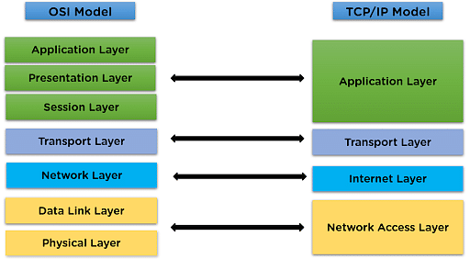
Source: https://www.simplilearn.com/tutorials/cyber-security-tutorial/what-is-tcp-ip-model

5. TCP/IP vs OSI Model: Comparative Analysis
OSI Model (7 Layers) | TCP/IP Model (4 Layers) | Protocols and Examples
7. Application | Application | HTTP, FTP, DNS, SMTP
6. Presentation | Application | SSL/TLS, ASCII, JPEG
5. Session | Application | NetBIOS, RPC
4. Transport | Transport | TCP, UDP
3. Network | Internet | IP, ICMP, ARP
2. Data Link | Network Access | Ethernet, MAC, PPP
1. Physical | Network Access | Cables, Hubs, Radio Signals

6. IPv4 vs IPv6: A Detailed Comparison
Feature | IPv4 | IPv6
Address Length | 32 bits | 128 bits
Address Format | Decimal (e.g., 192.0.2.1) | Hexadecimal (e.g., 2001:0db8::1)
Address Space | ~4.3 billion addresses | ~3.4×10³⁸ addresses
Header Complexity | 12 fields, 20 bytes | 8 fields, 40 bytes
Configuration | Manual or via DHCP | Stateless Auto-Configuration (SLAAC)
Security | Optional (IPSec) | Mandatory (IPSec is built-in)
Broadcast Support | Yes | No (uses multicast and anycast)
NAT Required? | Often used due to address exhaustion | Not required
Mobility Support | Limited | Native support for mobility and multihoming
Deployment | Widely deployed | Slowly replacing IPv4

